HOTEL REVENUE ANALYSIS

Project Overview
The Hotel Revenue Management – AI-Driven Revenue Analysis for Hotels project is designed to help hotel businesses understand and improve their revenue performance through data-driven insights using Power BI. The system analyzes booking data, occupancy patterns, guest demographics, pricing effectiveness, and seasonal trends to provide a comprehensive view of hotel operations. By calculating key performance indicators such as Occupancy Rate, Average Daily Rate (ADR), and Revenue per Available Room (RevPAR), the dashboard enables management to monitor performance across branches and room categories. The solution also incorporates guest segmentation, cancellation analysis, and forecasting techniques to predict future occupancy and revenue trends. Through interactive visualizations and strategic insights, the dashboard supports informed decision-making related to pricing strategies, promotions, upselling opportunities, and overall revenue optimization. This project demonstrates the integration of data modelling, business intelligence, and predictive analytics to enhance operational efficiency and profitability in the hotel industry.
Outcomes
- Developed an interactive Power BI dashboard to monitor hotel occupancy and booking performance.
- Calculated and visualized key revenue metrics including Occupancy Rate, ADR, and RevPAR.
- Analysed guest demographics and segmented customers based on stay purpose and loyalty.
- Identified booking trends, cancellation patterns, and lead-time distributions.
- Compared branch-level and room-category performance to evaluate revenue contribution.
- Implemented forecasting techniques to predict future occupancy and revenue trends.
- Provided data-driven insights to support pricing strategies, promotions, and upselling decisions.
Software & Hardware Requirements
Software Requirements
Component | Specification
BI Tool | Microsoft Power BI Desktop
Data Tool | Microsoft Excel
Data Transformation | Power Query
Calculation Language | DAX
Operating System | Windows (64-bit)
Deployment | Power BI Service

Hardware Requirements
Component | Specification
Processor | Intel i5 or higher
RAM | Minimum 8 GB (16 GB recommended)
Storage | 10 GB free disk space
System Type | 64-bit Architecture
Internet | Required for publishing & updates

Module 1: Data Modeling and Ingestion
Module Description
The Revenue Overview module presents a consolidated summary of the hotel’s financial and operational performance. It highlights overall revenue, profit, and room sales using calculated measures from the fact table. The dashboard enables management to analyze revenue trends over time, compare city-level contributions, and evaluate performance against targets. Interactive visuals provide quick insights into room category performance and monthly revenue fluctuations. Fig 1 represents the overall performance summary of the hotel business.
Key Metrics
Total Profit = SUM (Fact_Hotel_Revenue [Profit])
Total Bookings = COUNT (Fact_Hotel Revenue [Booking ID])
Rooms Sold = SUM (Fact_Hotel_Revenue [Rooms Booked])
Charts & Insights
Monthly Revenue – Line Chart
The Monthly Revenue line chart shows revenue trends over time and highlights seasonal fluctuations in booking performance. Revenue peaks during mid-year and early 2024, indicating strong demand periods. Some months show slight dips due to off-season effects. This helps management identify high and low revenue cycles.
Revenue by City – Bar Chart
The Revenue by City bar chart compares financial contribution across different locations. Chennai and Bengaluru generate the highest revenue, while Delhi contributes comparatively less. This indicates stronger market performance in southern cities. It helps in regional strategy planning and resource allocation.

Revenue Performance vs Target – Gauge Chart
The Revenue vs Target gauge chart compares actual revenue against the predefined benchmark. The total revenue of 414.29M significantly exceeds the target of 180M. This indicates effective pricing and occupancy management. It confirms that the revenue strategy is performing successfully.
Room Type – Donut Chart
The Room Type donut chart shows revenue distribution across Suite, Executive, Deluxe, and Standard rooms. The contribution is nearly balanced among categories. This suggests optimized pricing and consistent demand across room types. It ensures reduced dependency on a single category.

Module 2: Occupancy & Revenue Metrics
Module Description
The Booking Channel and Segment Analysis module evaluates revenue contribution across different booking sources and customer segments. It helps identify which channels generate maximum revenue and how different customer groups impact overall performance. The module also analyzes revenue by stay duration to understand booking behaviour patterns. These insights support channel optimization and targeted marketing strategies. These insights are present in Fig 2.
Key Metrics
ADR = DIVIDE ([Total Revenue], [Rooms Sold])
Total Revenue = SUM (Fact_Hotel_Revenue [Total Revenue])
Maximum Revenue = [Target Revenue] * 1.2
Charts & Insights
Revenue by Booking Channel – Bar Chart
The Revenue by Booking Channel bar chart displays revenue contribution from OTA, Corporate, Travel Agent, and Direct bookings. OTA and Travel Agent channels generate slightly higher revenue. This shows moderate reliance on third-party platforms. It helps evaluate distribution strategy effectiveness.
Segment-wise Revenue Contribution – Tree Map
The Segment-wise Revenue tree map visualizes revenue across customer segments. Revenue is evenly distributed without one dominant segment. This indicates a diversified customer base. It reduces risk associated with segment dependency.
Revenue by Stay Duration – Funnel Chart
The Revenue by Stay Duration funnel chart shows that longer stays contribute significantly higher revenue. Short stays generate comparatively lower income. This indicates extended bookings improve profitability. It supports strategies to encourage long-term stays.
Revenue Distribution by Channel – Donut Chart
The Revenue Distribution donut chart confirms balanced revenue share (around 24–26%) across booking channels. No single channel dominates revenue generation. This ensures stable multi-channel income streams. It reflects strong channel diversification.
Module 3: Guest Analysis Module
Module Description
The Guest Demographics and Loyalty Analysis module evaluates customer profiles based on nationality, age group, guest type, and loyalty status. It provides insights into the composition of the hotel’s customer base and identifies high-value customer segments. The module also analyzes the revenue contribution of loyal customers to assess retention effectiveness. These insights support personalized marketing, customer targeting, and long-term relationship strategies.Fig 3 shows the guest and loyalty analysis.
Key Metrics
Loyal Revenue = CALCULATE ([Total Revenue], Fact_Hotel Revenue [Loyal Customer] = "Yes")
Charts & Insights
Guest Nationality – Map Visualization
The Guest Nationality map visualization shows booking distribution across continents including Asia, Europe, and North America. This indicates international customer reach. It highlights the hotel’s global presence. It supports international marketing strategies.
Loyal Customer – Line Chart
The Loyal Customer line chart compares revenue trends from loyal and non-loyal customers. Loyal customers contribute consistently over time. This reflects effective retention strategies. It shows the importance of loyalty programs.
Guest Type Distribution – Donut Chart
The Guest Type donut chart displays distribution among Family, Solo, Business, and Couple segments. Each segment contributes almost equally. This indicates balanced demand patterns. It ensures stable occupancy across traveler types.
Age Group Analysis – Bar Chart
The Age Group bar chart shows higher bookings from 26–35 and 46–60 age groups. These represent working professionals and mature travelers. This identifies key target demographics. It supports personalized marketing decisions.
Stay Duration vs Profit – Scatter Plot
The Stay Duration vs Profit scatter plot shows a positive relationship between longer stays and higher profit. Family and Solo segments contribute higher profits during extended stays. This highlights the financial benefit of longer bookings. It helps improve pricing strategy

Module 4: Forecasting and Cancellation Trends
Module Description
The Cancellation and Booking Risk Analysis module evaluates booking cancellations, trends, and risk patterns across guest types and booking channels. It helps identify cancellation behaviour over time and measures the impact on overall revenue performance. The module provides daily cancellation rate tracking and comparative analysis among customer segments. These insights support better forecasting, overbooking strategies, and risk mitigation planning.Fig 4 shows the cancellation and forecasting trends.
Key Metrics
Cancelled Bookings = CALCULATE (
[Total Bookings],
Fact_Hotel_Revenue [Cancellation Flag] = 1
)
Cancellation Rate = DIVIDE ([Cancelled Bookings], [Total Bookings])
Charts & Insights
Cancellation Rate by Day – Line Chart
The Cancellation Rate line chart shows daily fluctuations between 15% and 22%. Some spikes indicate higher cancellation periods. The forecasted region shows expected variability. This helps in planning overbooking strategies.
Cancellation Trend – Gauge Chart
The Cancellation Trend gauge shows 1392 cancelled bookings overall. This represents a noticeable portion of total bookings. It highlights revenue risk due to cancellations. It supports active cancellation management.
Cancellation by Guest Type – Bar Chart
The Cancellation by Guest Type bar chart shows Business and Family segments have slightly higher cancellation counts. Corporate and group bookings may be more volatile. This identifies higher-risk segments. It supports targeted cancellation policies.
Booking Channel Distribution – Donut Chart
The Booking Channel donut chart shows cancellation impact is distributed across OTA, Direct, and Corporate channels. No single channel dominates cancellations. This indicates balanced cancellation risk. It ensures risk is not concentrated.
Cancellation Rate Breakdown – Decomposition Visual
The Decomposition Tree shows cancellation rates of around 17–19% for Family and Business segments. It allows drill-down analysis of cancellation behavior. It identifies root causes of booking drop-offs. It supports predictive risk planning.

Module 5: Revenue Strategy Dashboard
Module Description
The Strategic Revenue and Forecasting module provides advanced insights into profitability trends, revenue targets, and future performance projections. It analyzes cumulative profit patterns, property-wise profitability, and geographical contribution to overall earnings. The module also integrates revenue forecasting to support long-term planning and pricing strategy decisions. This dashboard serves as a decision-support system for executives and revenue managers(Fig 5)
Key Metrics
Upsell Index =
SUMX (
Booking_Fact,
Booking_Fact [Total_Revenue] * Booking_Fact [Nights]
)
Charts & Insights
Cumulative Monthly Profit Trend – Area Chart
The Cumulative Profit area chart shows profit trends across months. A gradual decline in later months may indicate seasonal slowdown or increased costs. It helps identify operational efficiency changes. It supports cost optimization strategies.
Revenue Forecast – Line with Confidence Interval
The Revenue Forecast line chart with confidence interval predicts stable future revenue with slight variability. The shaded region shows uncertainty levels. It helps management plan pricing strategies. It supports proactive decision-making.
Strategic Revenue Target – Gauge Chart
The Strategic Revenue Target gauge shows total revenue exceeding the 150M target. This confirms strong financial performance. It reflects successful revenue optimization. It validates pricing and occupancy strategies.
Property-Wise Profitability – TreeMap
The Property-wise Profitability tree map highlights that Hotel Grand Vista and Hotel Aurora contribute the highest profits. This identifies high-performing properties. It helps prioritize investment and expansion. It supports performance benchmarking.
Geographical Profit Breakdown – Waterfall Chart
The Geographical Profit waterfall chart shows cities like Chennai and Bengaluru contribute incremental profit growth. Each city adds to overall revenue positively. It highlights strong regional performance. It supports geographic expansion decisions.

Architecture Diagram

Snippets of Dashboard
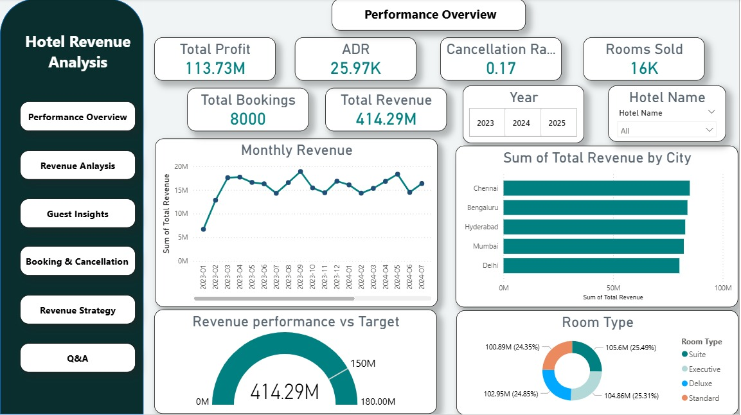
Fig 1. Performance Overview

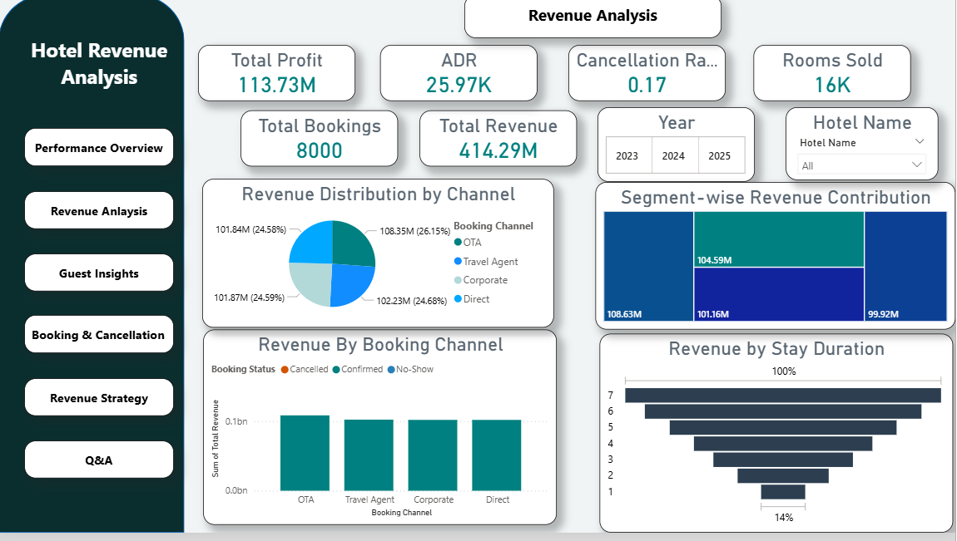
Fig 2. Revenue Analysis

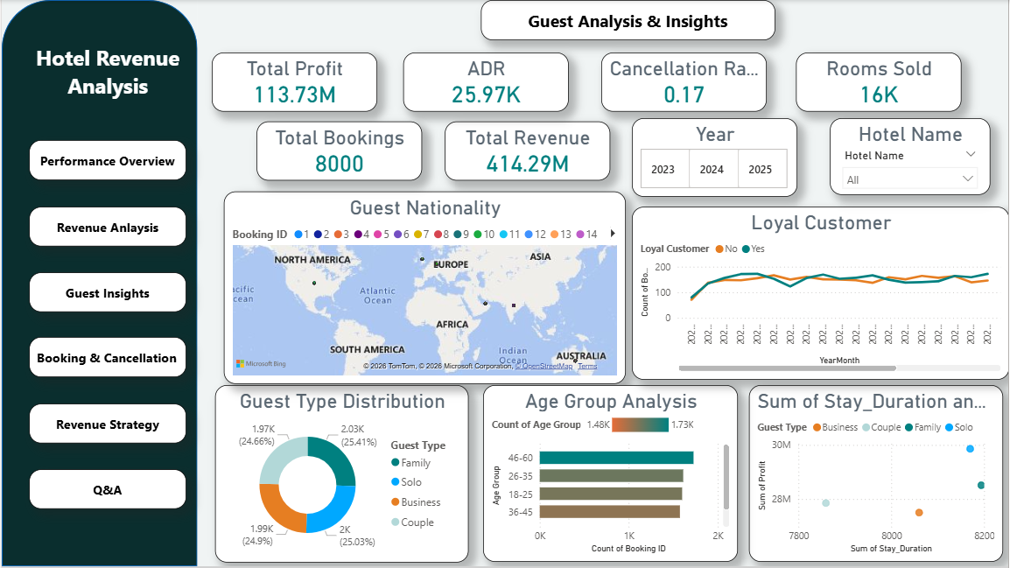
Fig 3. Guest Analysis & Insights
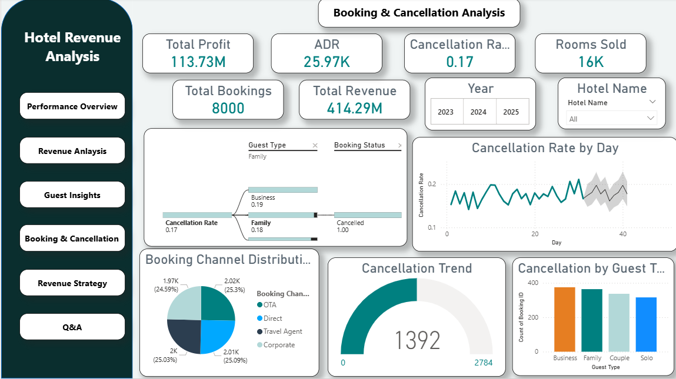
Fig 4. Booking & Cancellation Analysis
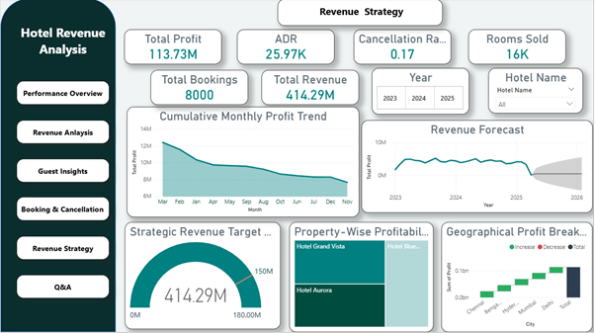
Fig 5. Revenue Strategy
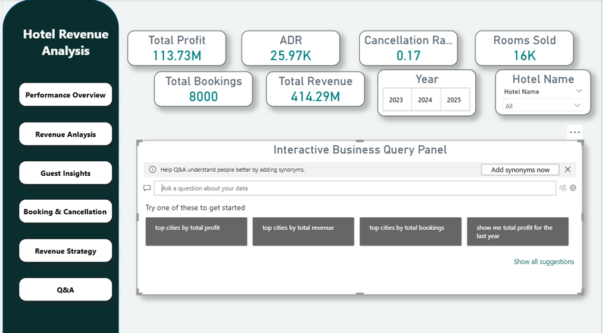
Fig 6. Q&A

Conclusion
The Hotel Revenue Management dashboard successfully demonstrates how business intelligence can be leveraged to improve decision-making in the hospitality industry. By integrating booking, customer, and revenue data into a structured Power BI model, the system provides clear visibility into occupancy trends, revenue performance, guest behaviour, and cancellation patterns. Key metrics such as Total Revenue, ADR, Profit, and Cancellation Rate enabled performance monitoring at both branch and segment levels. The forecasting and strategic analysis modules further supported proactive planning and revenue optimization. Overall, the project highlights the effectiveness of data modelling, DAX calculations, and interactive visualizations in transforming raw hotel data into actionable business insights.
Future Enhancements
- Implement advanced machine learning models for more accurate revenue and occupancy forecasting.
- Integrate real-time data from booking engines and hotel management systems.
- Develop dynamic pricing recommendations based on demand patterns and competitor analysis.

